Sreenath Reddy
11/105/2012
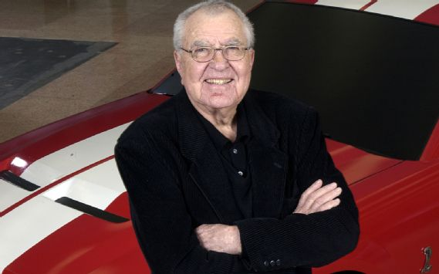
Automotive Legend Carroll Shelby Dies at 89
The legendary Carroll Shelby has left us at the age of 89, passing away yesterday at Baylor Hospital in Dallas. The cause of death was not disclosed. Shelby's story was quintessentially American. He was a rural Texan, a World War II pilot and flight instructor, an oil-field laborer, and a chicken farmer in bib overalls whom some say turned to racing when all his chickens died. Whatever the catalyst, Shelby demonstrated a natural knack for road racing from the moment he took the wheel of a wheezy MG TC in 1952, seeking the adrenaline rush of speed he'd become addicted to while flying in the war. He managed to outperform many more powerful cars in that teetering MG, and soon matriculated to a "real" race car -- a Cadillac-powered Allard J2 -- and won an SCCA event in Caddo Mills, Texas. From that moment on, he was hooked on the big Yankee V-8/lithe British chassis formula.
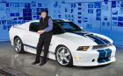

In 1954, John Wyer, then team manager of Aston Martin, enlisted Shelby to run in both Sebring and Le Mans (co-driving with Paul Frere) in an Aston Martin DBR3. Later that year, Shelby was seriously injured while competing in the Carrera Pan Americana Mexico, flipping his Austin Healy four times after T-boning a rock. His significant injuries wouldn't stop him from racing just months later at Sebring in a 3.0-liter Monza Ferrari (co-driving with Phil Hill) with his arm in a special cast and his hand taped to the steering wheel. There was no denying Shel was one tough son of a gun.
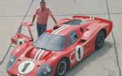

As his racing career started gaining steam, he began to be recognized nationally and internationally. In 1956 and '57, Sports Illustrated named him Driver of the Year. Two years later, while co-driving with Roy Salvadori for the Aston Martin factory team, he won Le Mans. A diagnosis of angina ended his racing career in 1960 (part of a lifelong battle with heart disease), but not before he won the USAC driving championship that year. By then racing had become his passion, and he kept his hat in the ring, picking up a Goodyear Racing Tires distributorship and opening a high-performance driving school with Peter Brock as an instructor.
But Shelby longed to build his own car, and soon enough, the planets aligned. In 1961, when AC Cars in England lost Bristol, its engine supplier, Shelby contacted the company and outlined a plan to use the chassis to build a V-8-powered sports car, which AC approved. Shelby's pal Dave Evans inside Ford helped him secure a deal to buy small-block V-8s, and he acquired fellow racer Lance Reventlow's race-car building enterprise, which was falling on hard times. Within a matter of months Shelby had a chassis, an engine (a 260 cubic-inch Ford V-8), a building to assemble them in, and the engineering brains behind Reventlow's operation, Phil Remmington.
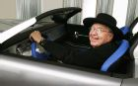
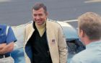
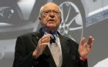
Shortly after the first AC 260 Roadster chassis arrived at Shelby's Southern California shop in February of 1962, Shelby said he had a dream about what to name the car. "I woke up and jotted the name down on a pad which I kept by my bedside -- a sort of ideas pad - and went back to sleep. Next morning when I looked at the name 'Cobra', I knew it was right," Shelby said in a 1993 interview. And so the Cobra was born.
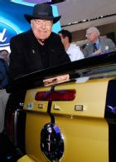

The first shiny yellow CSX 2000 Cobra was introduced to the world in April, 1962, at the New York auto show. The car was repainted several times during its rounds with the automotive press to give the impression that Shelby had more than one prototype. (In 1999, we named the CSX 2000 the most significant car of the last 50 years.) After production and other engineering teething issues were addressed, it wasn't long before long before his fledgling company -- Shelby American -- was building powerful and lightweight Cobras that quickly began dominating at the track with the likes of fellow motorsports legends Dan Gurney and Phil Hill behind the wheel. Success brought new business to Shelby's door, namely from Ford, due in part to his connections at the automaker and the fact that Cobras were Ford-powered.
In 1964, Ford and Shelby began their first official Mustang collaboration, launching the 1965 Shelby Mustang GT350 for both SCCA B-production spec racing and the street -- marking the beginning of a golden age for Shelby American on the track and in the showroom.
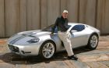

Several of the most iconic cars in Shelby's history were produced during this period, including the 427 Cobra Roadster and the Cobra Daytona Coupe, which would take first overall at the Sebring 12-Hour in 1965 with Bob Bondurant at the helm and went on to win multiple events worldwide. Shelby also was instrumental in developing several of the most sought-after track and street Mustangs in history, including the Shelby GT500 and Trans-Am racers.
Shelby is also forever linked with the legendary Ford GT-40 series cars. Beginning in 1965, Shelby and Ford led an all-out American assault on European sports car racing with the Daytona Coupe and GT-40, culminating in the GT-40's historic 1-2-3 finish at the 1966 Le Mans 24 Hour, humbling the mighty Ferrari juggernaut as Henry Ford II proudly looked on. The GT-40s won Le Mans the following year as well. While Shelby didn't build the GT-40s, he and his team were instrumental in its development and racing success.
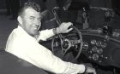
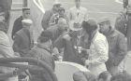
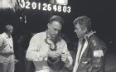
As the musclecar era drew to a close, so did Shelby's era with Ford. Production of the Shelby Mustang ended in late 1969, and Shelby's team racing agreement with Ford was terminated shortly afterward. In the intervening years, Shelby kept himself busy marketing his chili mix (which he later sold to Kraft) and starting the Shelby-Dowd wheel company in 1973. The Shelby-American Automobile Club was founded in 1976 and he traveled the world extensively, including an extended stay in South Africa.
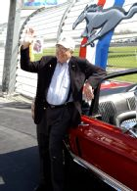

In 1982, Chrysler came calling. Mustang godfather Lee Iaccoca, who had become the CEO of Chrysler, enlisted his old pal Shelby to inject some performance sparkle there, which led to the "Goes Like Hell" Omnis, Shelby Chargers, Lancers, Shadows, and even a Dakota pickup through the '80s. Shelby was also an advisor in the development of the Dodge Viper-, which Bob Lutz conceived as a modern-day Cobra, and drove the prototype Viper that paced the Indy 500 in 1991 -- less than a year after his heart transplant. (He would later undergo a kidney transplant and become the oldest surviving double transplant recipient in history.) Shelby later founded the Carroll Shelby Children's Foundation to help fund organ transplants for children in need.
While Shelby was lauded for his charity work and other worthwhile endeavors, he was also noted for his litigiousness, several shaky business deals, and lengthy feuds. In 1988, Shelby sued Ford over the use of the GT350 name it used on its 1984 20th anniversary Mustang, and the case was settled in 1990. Over the years, Shelby also did trademark battle with several makers of knockoff Cobras and companies using the Cobra name and shape, including, ironically, AC Cars and Cobra replicar makers Superformance International, Inc. and Factory Five, Inc. He even got into a well-publicized row with the Shelby-American Automobile Club over what he believed to be mismanagement at the organization.
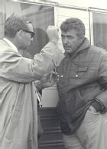

Not surprisingly, Shelby was also the target of numerous suits and countersuits, most notably by customers of Unique Performance, a Shelby Mustang continuation company he partnered with, who claimed they didn't get the cars they paid for when the company was shut down during a criminal investigation for title washing. He battled with Wilhelm Motor Works, another Shelby Mustang continuation company, over a licensing dispute. Shelby was also sued twice by Denice Halicki, widow of "Gone in 60 Seconds" creator H.B. Halicki, over the use of "Eleanor," the name of the Mustang that starred in the original 1974 movie.
Shelby's last clean-sheet new-car design -- the 1999 Series 1 -- was to have been a 2400-pound, 500-hp supercar, but development problems, government red tape, and corporate politics caused the car to come to market late, overpriced and overweight, underpowered and underdeveloped. Other projects, including attempts at a Shelby motorcycle, didn't fly.
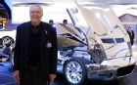

By 2004, Shelby was back where he started, collaborating with Ford on 2004's Shelby Cobra Concept Car and 2005's GR-1 coupe- -- a faithful homage to the Pete Brock Cobra Daytona coupe rendered in unpainted aluminum polished to a chrome finish. He also consulted on the design of Ford's centenary birthday present to itself, the 2005-2006 Ford GT. Since then, the Shelby name has returned to a brace of different Mustang models, some built by Shelby out of his Las Vegas factory, and some by Ford.
In a July 2008 interview in Mustang Monthly, Shelby expressed his thoughts about his renewed relationship with Ford: "I never dreamed I would be back with Ford to the extent that we are today, but I'm very pleased we are. I'm a lucky man that, at 85, I have such a wonderful partnership with Ford."
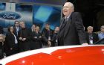

Befitting his status as a living legend, Shelby was showered with awards and accolades. He was inaugurated into the Automotive Hall of Fame and the International MotorSports Hall of Fame, just to name a few. And in 2006, we named him one of the 50 most important people in the auto industry in our annual Motor Trend Power List.
Should Carroll Shelby be remembered as America's Enzo Ferrari? While the company he leaves behind doesn't have the same lineage, the iconic cars he created -- and the legacy he leaves behind -- are no less enduring.
