Sreenath Reddy
EcoBoost Power Coming to the 2013 Ford Transit
Familiar Engine, New Van Body

sreenath
3/3/2012

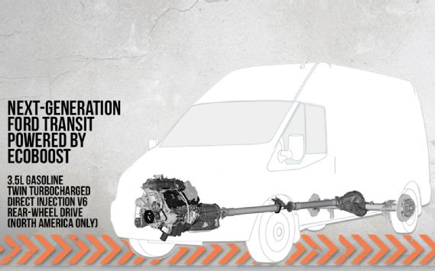When Ford announced back in December it would replace its venerable E-Series van with a version of the next-generation, European-developed Transit, details weren't exactly forthcoming. But we're slowly starting to learn more about Ford's new people-carrier, including what will power it. Ford has just announced that the 2013 Ford Transit will receive the much-lauded 3.5-liter EcoBoost V-6 currently in service under the hood of the F-150 and numerous other Ford offerings.
The announcement was made at the National Truck Equipment Association Work Truck show in Indianapolis. Ford divulged just one specific detail on the Transit EcoBoost: It will be a rear-drive model. We don't yet know if all-wheel drive will be an option.

We do know that the U.S.-spec Transit is likely to be called the T-Series. It will be built at Ford's Kansas City Assembly Plant in Missouri, with production starting later this year. Though we don't know the transmission options or power specs for the Transit's EcoBoost, it is unlikely to deviate much from the F-150's, which has become a popular option for Ford truck buyers.
In the F-150, the engine is paired to a six-speed automatic good for 365 hp and 420 lb-ft of torque. Exterior styling will bear elements of Ford's "kinetic design" language, and shouldn't be wildly different from that of the Ford Tourneo Custom Concept Ford is unveiling at the 2012 Geneva Motor Show.

