Is this the car that spurred the Mazda-Alfa deal?
The Alfa Romeo 2uettotanta may have prompted Fiat to find a Partner for a 21st-century Duetto Spider.
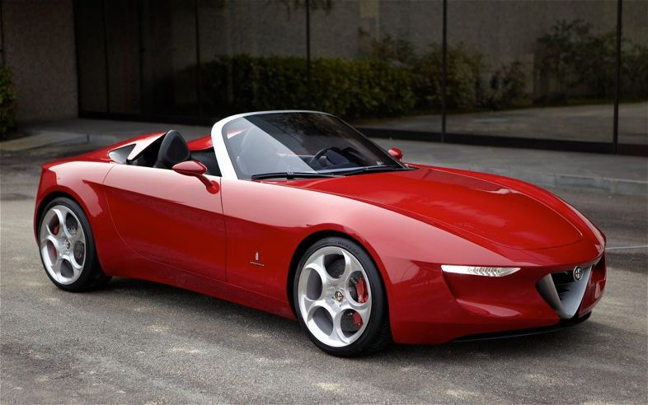

Rumor and speculation say that Pininfarina's 2010 Geneva auto show concept, the Alfa Romeo 2uettotanta, prompted Fiat to find a strategic alliance partner that would supply a small rear-drive platform for a 21st-century Duetto Spider. Mazda and Alfa Romeo have announced that a new, small Alfa roadster will be built off the next MX-5 Miata platform.
The next Mazda Miata is expected in the 2014 model year, while the Alfa, with unique sheetmetal, interior, and a Fiat-supplied engine, will go on sale in the '15 model year.

The Alfa almost certainly won't be this car, though some of its design cues might be applied. The 2uettotanta's proportions are a bit off, with a hood and dash-to-axle that's too long for the next-generation Miata.
More important, Alfa Romeo's design staff isn't likely to cede responsibilities for such a high-profile car to a supplier, even if it's named Pininfarina.

