The Toyota Smart Insect Concept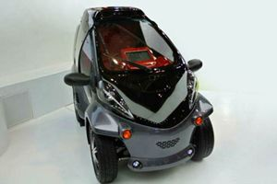
MELBOURNE: A new concept car has been developed by a Japanese automobile company that monitors your face to help predict what you'll want to do next.
The Toyota Smart Insect Concept is has motion sensors, voice recognition and behaviour prediction technology to monitor the driver's face and activate in-cabin features, foglights - or even set a destination in their smartphonesatellite navigation - after interpreting the information, Carsguide.com.au reported.
The concept car also talks to the drivers they recognize as they approach the car, flashing its lights and typing "hello" and other responses on its instrument panel monitor, and opening the door at a wave of the hand.
The car is linked to a "virtual agent" by a cloud connection at Toyota, which changes the settings remotely, and also connects to the driver's home, allowing them to reset the car's locks and air conditioning before they head out the door.
The company unveiled the Smart Insect - an acronym for Information Network Social Electric City Transporter - at the huge CEATEC advanced technology show in Japan.

