11/105/2012
We had the best
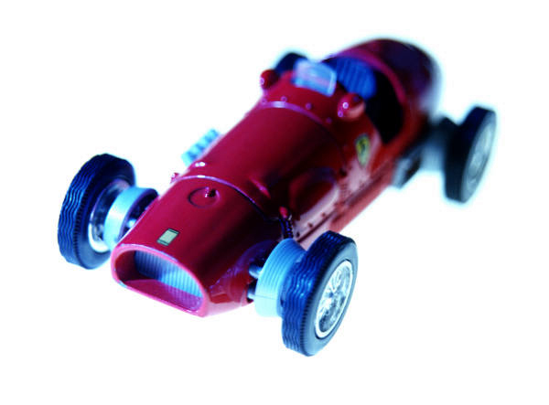
Sreenath Reddy | Toyota Special Awards

Special awards
Two Top "Engine of the Year Awards 2000" for Toyota
Both Yaris and Prius win "Hi-tech" engine awards for the 2nd year running
Yaris engine VVT-i - the winner
In 2000 Toyota's "Hi-tech" hybrid technology Prius, and fuel-efficient Yaris VVT-i engines have both received "Engine of the Year" awards from an international jury of automotive journalists - for the second year in a row. 1999 top award went to the Yaris' powerful yet fuel-efficient VVT-i engine, with the Prius being awarded "Best Eco-friendly" engine - an achievement that has been repeated in 2000.  The Yaris - which in 1999 won the very top "Engine of the Year" award for its 1.0 litre VVT-i engine - in 2000 took the Engine of the Year award in the 1.0 to 1.4 litre category, with its 1.3 litre VVT-i engine. The Yaris - which in 1999won the very top "Engine of the Year" award for its 1.0 litre VVT-i engine - in 2000 took the Engine of the Year award in the 1.0 to 1.4 litre category, with its 1.3 litre VVT-i engine.
  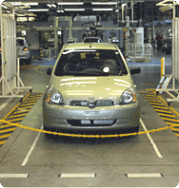
Variable Valve Timing-intelligent (VVT-i) technology - around which this winning engine is based - controls the intake valves, closing them sooner at low engine speeds to reduce knocking, and leaves them open at high speeds to reduce pumping losses to the cylinder. Toyota's VVT-i technology can also vary the valve timing along a 60-degree continuum, providing the optimal amount of air, providing efficient combustion at all engine speeds.
Toyota is not only a leader in developing fuel-efficient engines. It has also developed a high-tech hybrid engine system - the Toyota Hybrid System (THS) - which combines petrol and self-charging electric technology. Toyota has successfully put this system into practice with its Prius model, launched in Japan in 1998, with the second generation launched in Europe in Autumn 2000. Prius took the prize in the "Best Eco-friendly" category in 1999 awards, and the jury awarded Prius top prize in this category again in 2000.
"At Toyota we have focused our engines on the future. We have developed engines that reduce harmful emissions into our atmosphere and improve vehicle fuel efficiency, while making certain to continue to provide our customers with both comfort and driving pleasure".
"We feel that our engine technology is one of our greatest assets. The diversity and quality they display is a good representation of what our technical, engineering and design staff have worked hard to achieve. Winning the Engine of the Year award further confirms the industry's recognition of our efforts, and makes us feel very proud."
"In the end," continued Mr. Nakagawa, "the enthusiasm and satisfaction of our customers are the real judges of the quality of what we produce".

