Sreenath Reddy

12
Why Young People Are Driving Less
Is the automobile over?

Why Young People Are Driving Less
Is the automobile over?
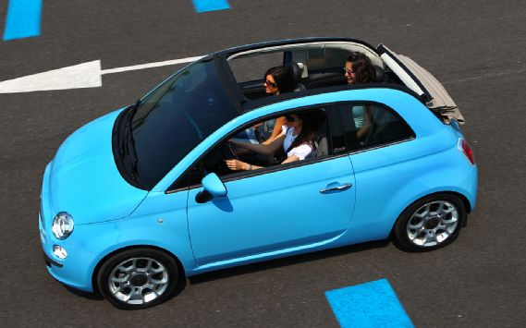

Automakers pitch new small cars, from the Fiat 500 to the Ford Fiesta and Chevrolet Sonic to the Acura ILX, as models designed to appeal to America's urban-oriented Generation Y. Marketing experts fill product presentations with statistics and anecdotes of how tuned-in youth fetishize smartphones, the Internet, and keeping in touch with friends via Facebook from their loft apartments in "walkable" cities.
The problem begins with the assumption that youth moving back to the cities want A- or B-segment hatchbacks, when they're more likely to spend the money on smartphones, tablets, laptops, and $2000-plus bikes.
Gen Y has car enthusiasts, of course, just like every other age group. As always, car enthusiasts are a minority. Today's young people appear to have less interest in driving and owning a car than do their mainstream, non-enthusiast older counterparts.
The Great Recession's effect on the ability of 16- to 34-year-olds to find a good-paying job has exacerbated this, according to the Frontier Group's study, "Transportation and the New Generation," by Benjamin Davis and Tony Dutzik, released last spring. If the U.S. automotive market has truly recovered from its 10.4-million-unit nadir in 2009 to an expected 13.5- to 14-million this year, it's without much help from the under-35 age group.
The share of 14- to 34-year-olds without a driver's license was 26 percent in 2010, up from 21 percent in 2000, the study says, quoting the Federal Highway Administration. In 2009, the 16- to 34-year-old age group took 24-percent-more bike trips than in 2001, even as its population shrank by 2 percent. The same age group walked to more destinations in '09 than in '01, and the distance it traveled by public transit increased 40 percent

Young people are returning to big cities and to near-urban, walkable suburbs, co-author Dutzik says. Many remain "connected" via smartphone for their entire mass transit commutes to and from work. They also are more interested in saving the planet, he says, though the economy remains the biggest factor. These young non-drivers are weaning themselves from cars, and won't necessarily rush to buy them when the job market improves.
"The economics of driving are still going to be different for young people," Dutzik continues, citing Department of Energy projections for future oil prices. While gas prices faithfully deflated after each oil shock we've had since 1973, the Frontier Group doesn't expect gas to come down much below $3.50 per gallon from here on.
Besides new mass-transit and proposed rapid-transit projects like controversial high-speed rail, Dutzik points to car-sharing services like ZipCar and smartphone apps that can tell you how long before the next bus arrives at your stop.
"
Non-drivers are weaning themselves from cars and won't necessarily rush to buy them when the job market improves.
"
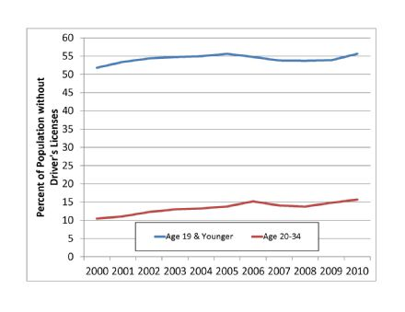
The Frontier Group's study is designed to "issue a wake-up call for where you spend the money," Dutzik adds. Along with new alternatives, this means reallocating Federal Highway Trust Funds to existing roads that need repair, rather than to expanding roads or building new ones.
Our lack of a coherent federal transportation policy and the notion of spending Federal Highway Trust Fund monies on mass transit rather than roads is an age-old political hot button. But the Trust Fund doesn't cover 100 percent of new highway projects. New mass transit projects face strict approval processes, while new highways are easily approved, Dutzik says.
"We need a pretty frank and clear debate about what our transportation priorities are," he concludes. If Generation Y has its say, cars and new highways won't be a big part of that priority.

Too many models chasing too few buyers?
Will modern youth's aversion to cars and driving affect the auto industry? Automakers without full lineups, like Subaru, Mazda, Mitsubishi, and Suzuki already are on notice, while companies like Fiat, Peugeot Citroen PSA, and Opel/Vauxhall struggle in their home markets.
In North America, automakers have cut capacity from about 23 million units annually before the 2008 Lehman Brothers collapse, when sales peaked just above 17 million, to a lower, unknown number. No one seems to have a reliable capacity estimate, though it's certainly still higher than the 13.5- to 14-million cars and trucks Americans will buy this year.
Though automakers doing business in North America and Western Europe are seeking ways to cut capacity without causing excessive labor union pain, they're continuing to split automotive segments into "micro-niches."
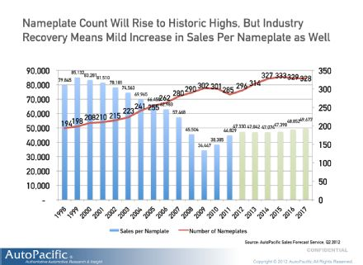
In October 2006, AutoPacific estimated there would be "at least" 324 nameplates on the U.S. market by 2011, part of its ongoing "atomization" analysis. This counts, for example, the Volkswagen Jetta as one nameplate, and doesn't separate the TDI, wagon, or trim levels.
Since that study, the Great Recession has put an end to the 17-million unit years, and has taken with it Pontiac, Saturn, Saab, Hummer, and Mercury. Last year, there were 285 nameplates on the market instead of the 324 it projected before those brands disappeared, AutoPacific says.
The Germans are continuing to break out more new niche models, says Ed Kim, AutoPacific's vice president for industry analysis. Commonized, rationalized architecture is making this economically feasible, and it's easier for a high-margin luxury model to make money for an automaker than it is for a commodity model. So the next major economic downturn is likely to have one or both of these effects on the auto industry; (1) Commodity brands will have to take advantage of the relative health and margins of premium and luxury models (see, 2014 Chevrolet Impala, Ford's Titanium trim levels); (2) We will lose more brands. Unless Gen Y finds high-paying jobs and has a collective "eureka" moment about the joys of personal automobile ownership.

